PENGUJIAN ANTARA WINDOW WSL UBUNTU – LINUX UBUNTU

- PENGUJIAN WINDOW WSL (UBUNTU)
  - CPU Benchmark
    - jalankan sysbench cpu run
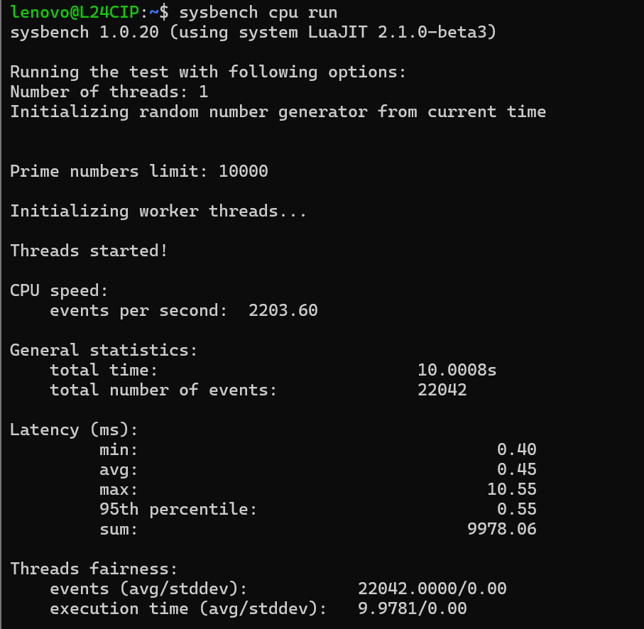
1.2.1 jalankan sysbench cpu --cpu-max-prime=2000 --threads=4 --time=30 run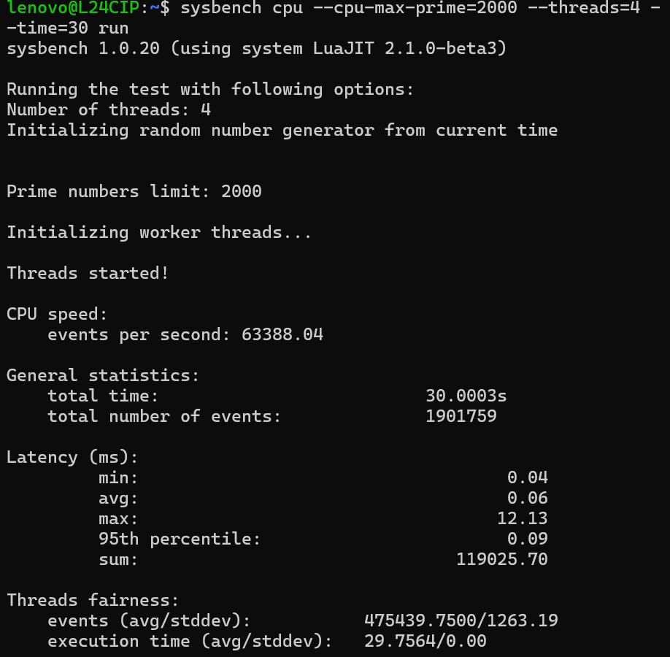

  - Memory Benchmark (RAM)
    - jalankan sysbench memory run
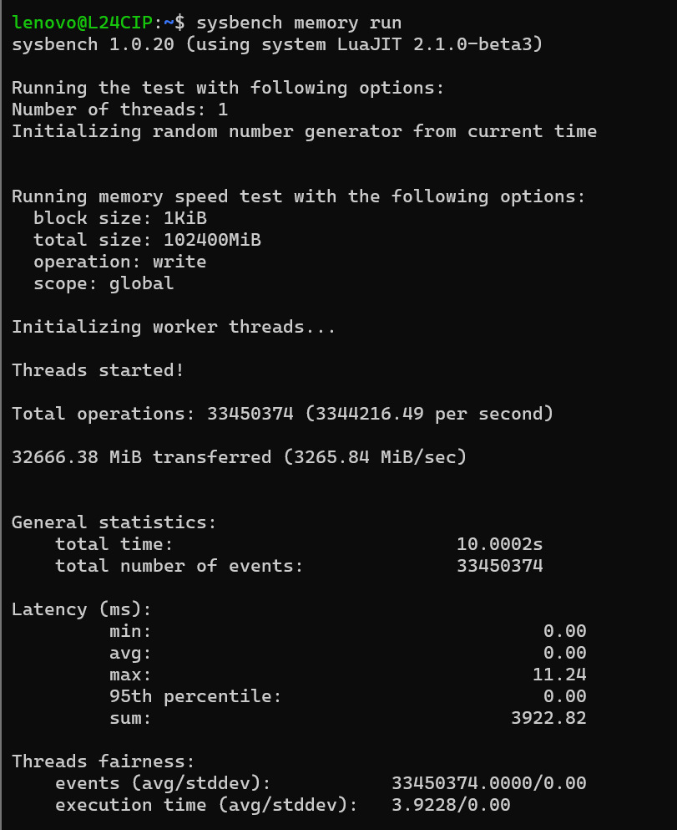
1.2.2 jalankan fileio –file-total-size=2G prepare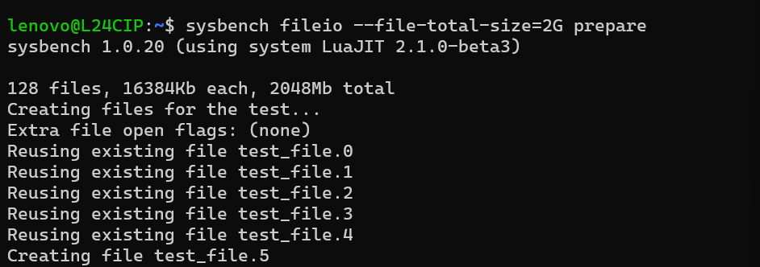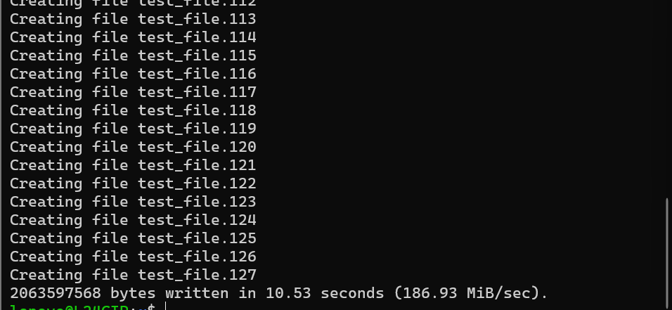

  - File I/O Benchmark
    - jalankan sysbench fileio --file-test-mode=rndwr run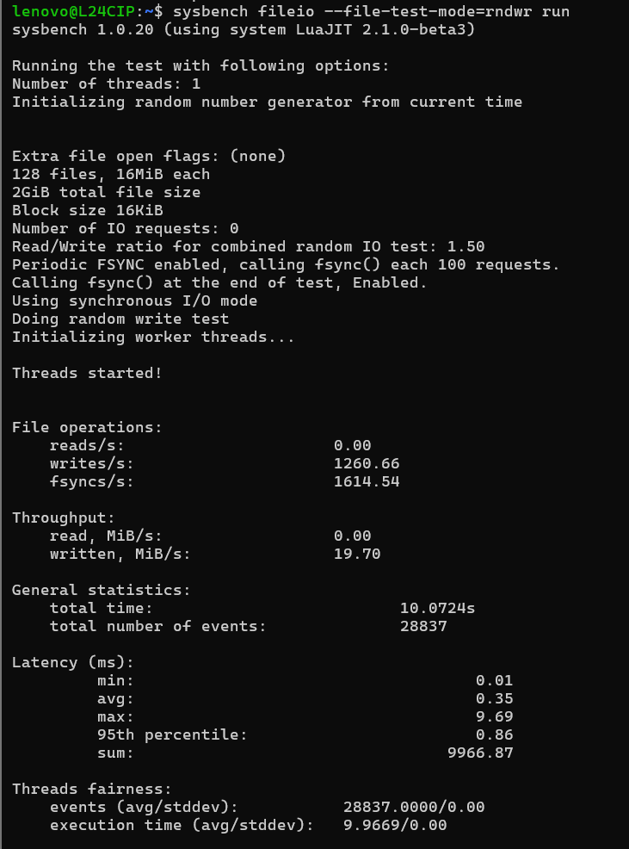

- PENGUJIAN LINUX UBUNTU
  - CPU Benchmark
    - jalankan sysbench cpu run
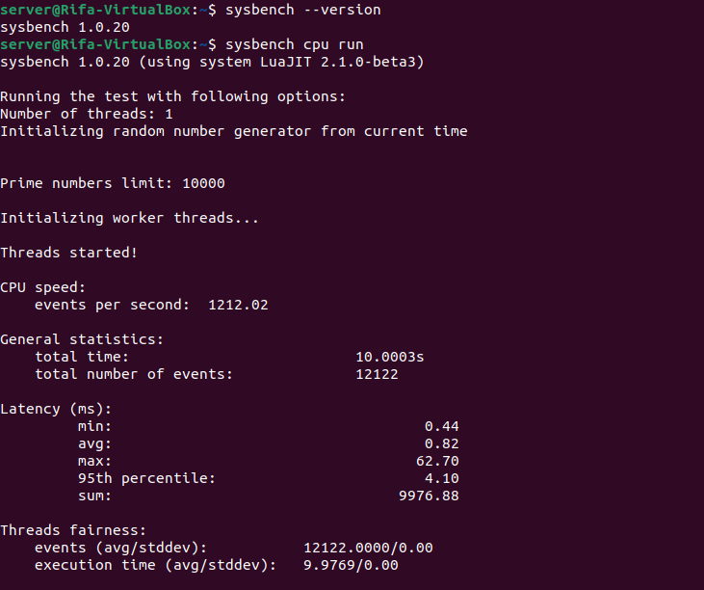
    - jalankan sysbench cpu –cpu-max-prime=2000 –threads=4 –time=30 run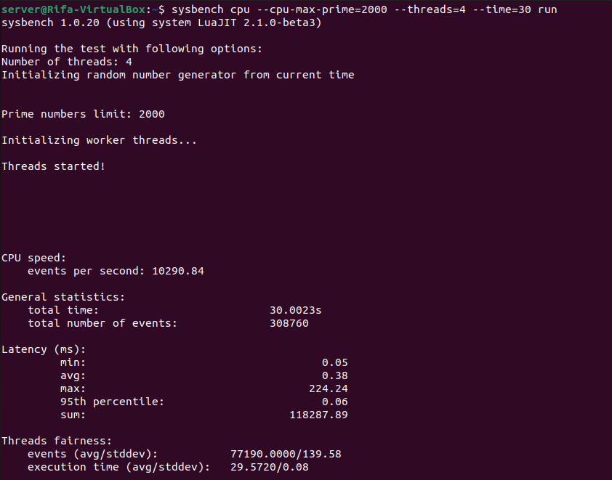

  - Memory Benchmark (RAM)
    - jalankan sysbench memory run
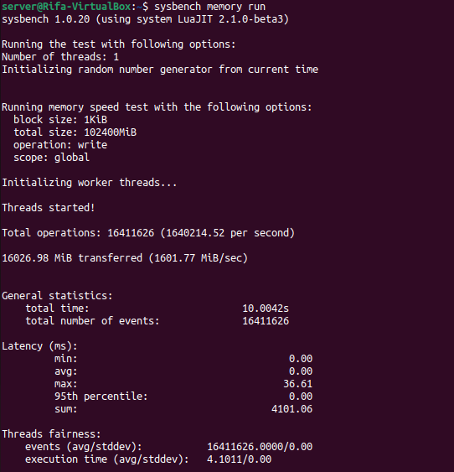
    - jalankan sysbench fileio –file-total-size=2G –file-num=5 prepare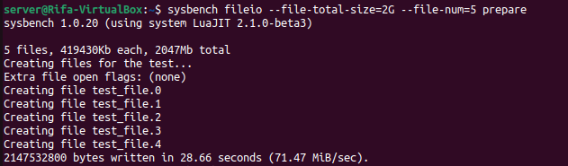
  - File I/O Benchmark
    - jalankan sysbench fileio –file-total-size=2G –file-num=5 –file-io-mode=async –file-fsync-freq=0 –file-block-size=1M run